Name: Callejo, Jaff Raine Jay V. Date Submitted: November 6, 2025
Course, Year and Section: 2a Subject: Platform Technologies

Last Alison Course Certificate (Laboratory Activity):
Alison Course Completion + Understanding Bash Scripting & Commands
Activity Title:
Understanding Bash Scripting & Commands
Course Link:
https://alison.com/course/understanding-bash-scripting-and-commands?authuser=0

Screenshot 1 – Landed on the page with the Start Learning
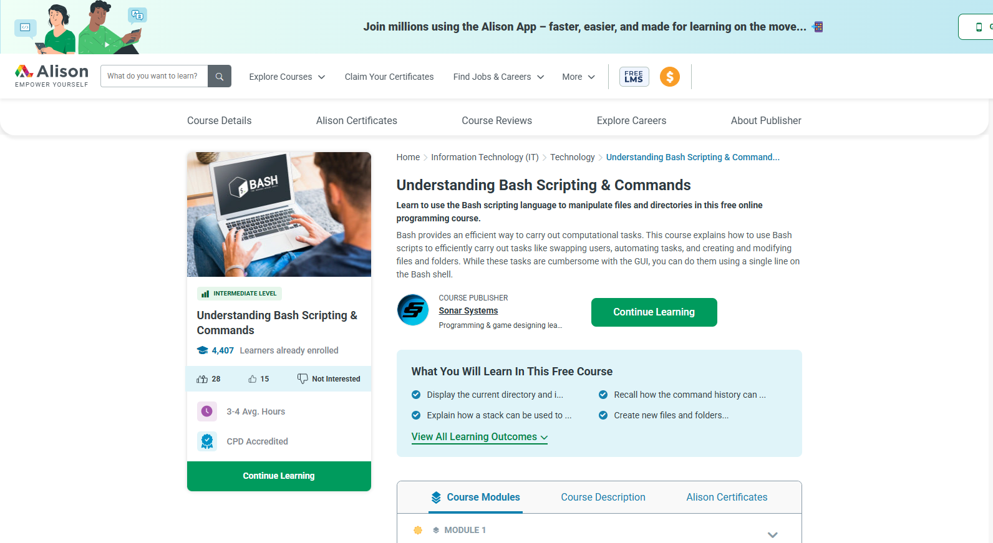

Screenshot 2 – Reading or Watching Through the Materials.
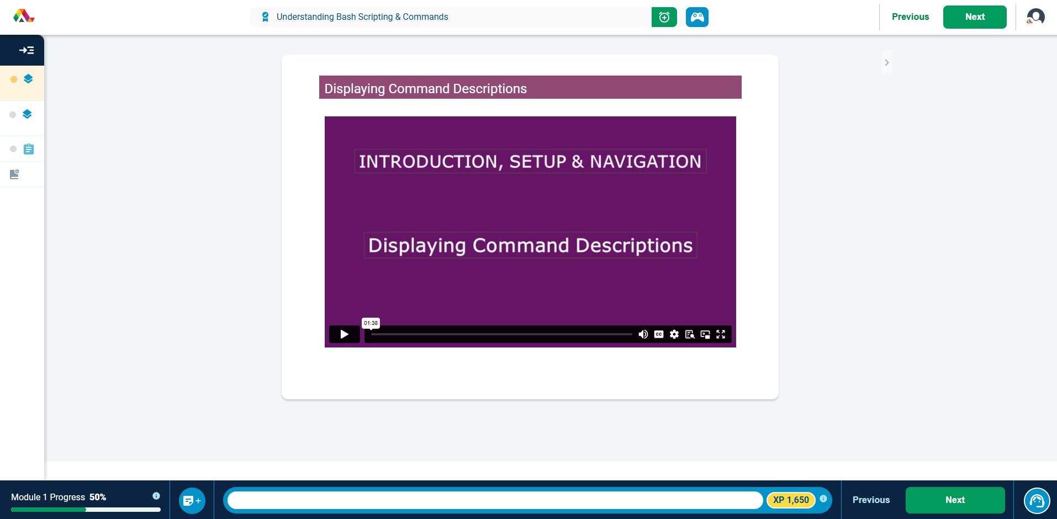

Screenshot 3 – Answering Questions within the Module.
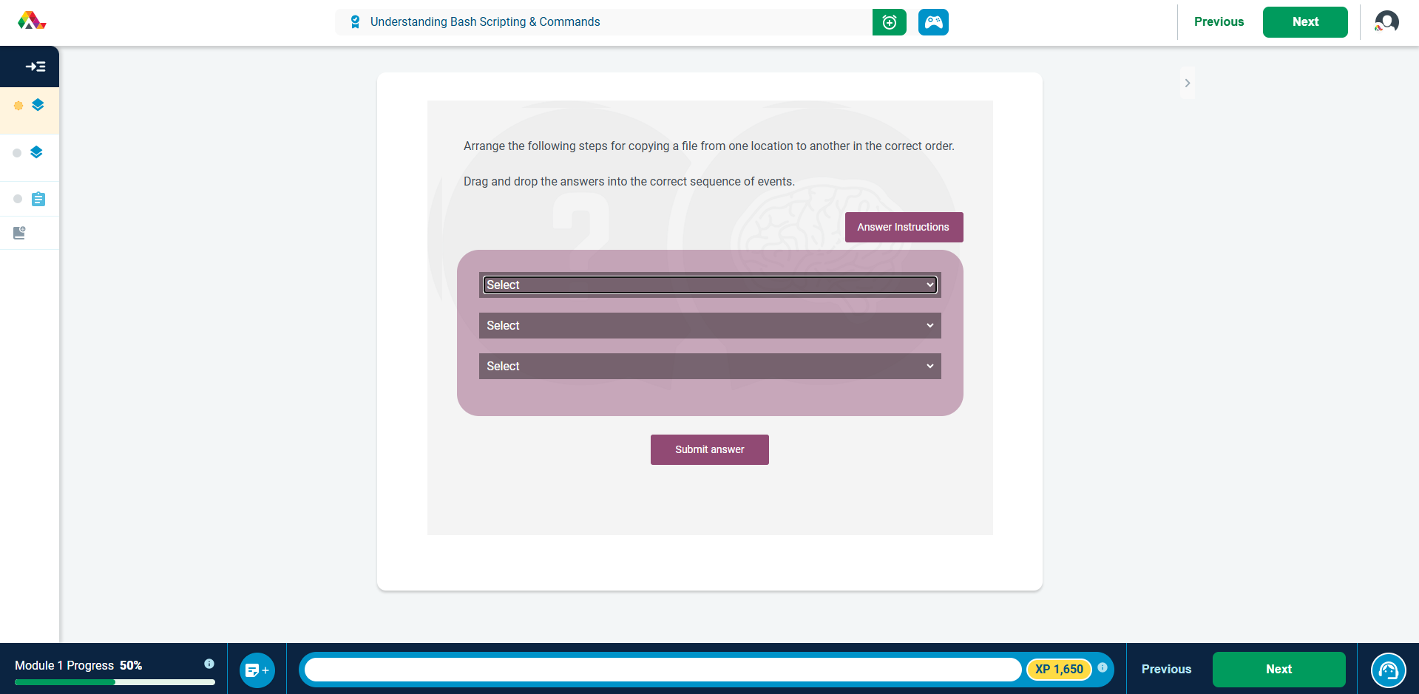

Screenshot 4 – Certificate Screenshot


Reflection on Bash Fundamentals
This study session focused on building a strong foundation in Bash Scripting, covering essential terminal commands and navigation techniques. The first key area was administrative control, where I clarified the functions of core commands: sudo grants temporary superuser access to run a single command with elevated permissions, su switches the entire shell session to another user (like root), and id is used to display user and group identification numbers.
Next, I focused on improving command-line efficiency using key shortcuts. Instead of slow arrow-key navigation, Ctrl + E instantly moves the cursor to the end of the line, while Alt + B and Alt + F allow for quick, word-by-word movement forward and backward. This set of shortcuts significantly speeds up editing commands.
Another vital concept was the directory stack, which enables faster file system navigation. The pushd command adds the current directory to a temporary stack before moving to a new one, popd removes the last-added directory from the stack and moves the user there, and dirs simply displays the list of directories currently in the stack.
Finally, I reviewed the correct structure for creating a reusable Bash Function. The steps are to: 1) enter the optional function keyword, 2) specify the function name followed by brackets (), and 3) enclose all the lines of code to be executed within curly braces {}. Mastering these fundamentals transforms the command line into a much more capable and efficient tool.

